

**Figure 3:** PRISMA flowchart summarizing the litterature review and inclusion process.

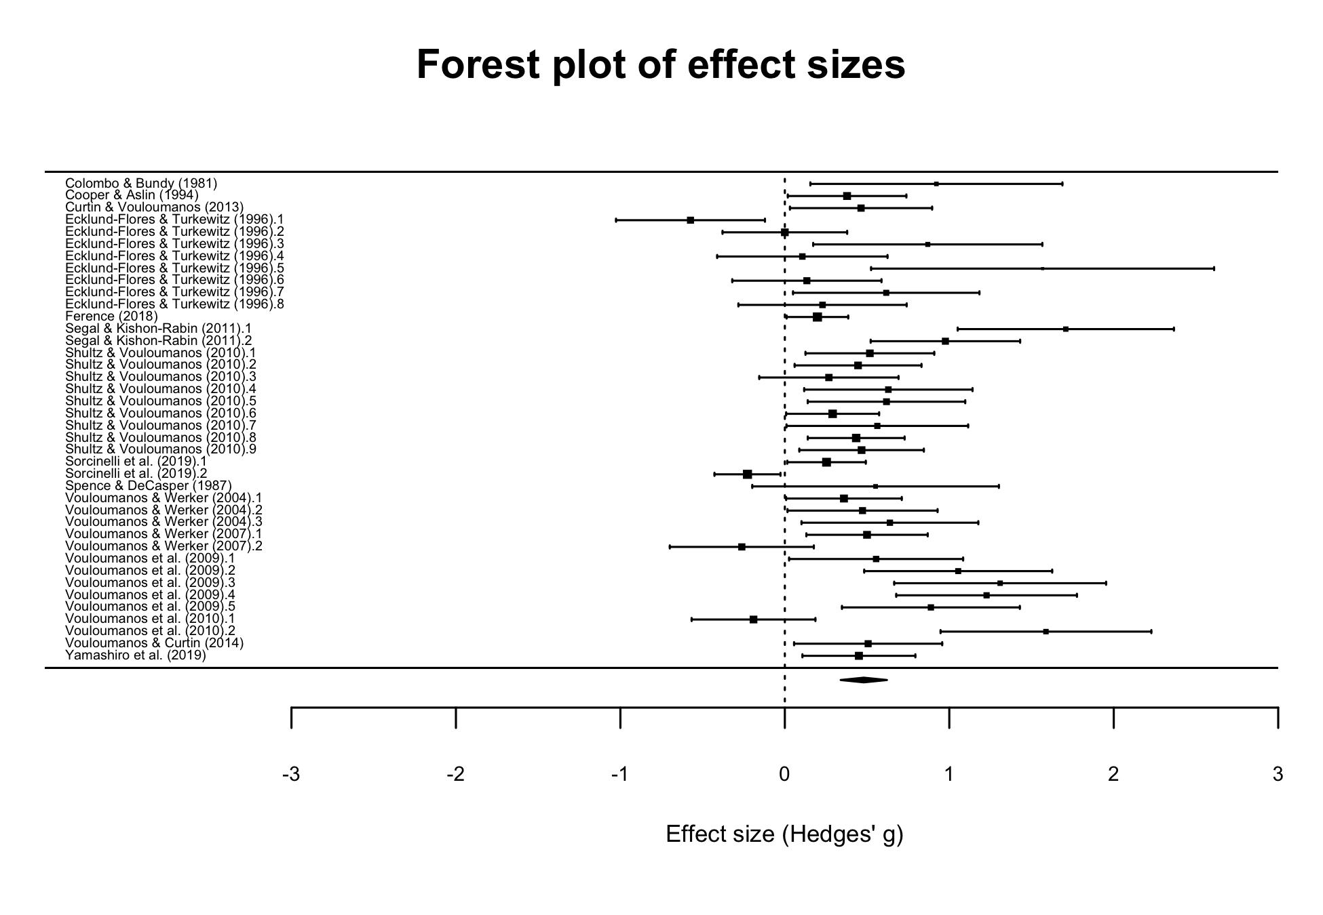

**Figure 4:** Effect sizes of individual studies with corresponding confidence intervals (upper part), and summary effect size across the literature (diamond, lower part). The size of the square is proportional to the weight of each effect size in the meta-analytic model.

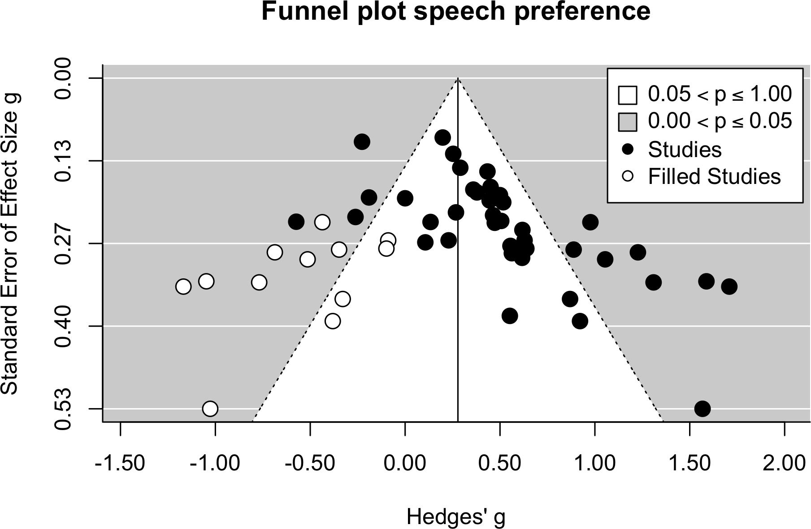

**Figure 5:** Funnel plot of study precision as a function of effect sizes. The vertical line corresponds to the estimated effect size after adding the missing studies.